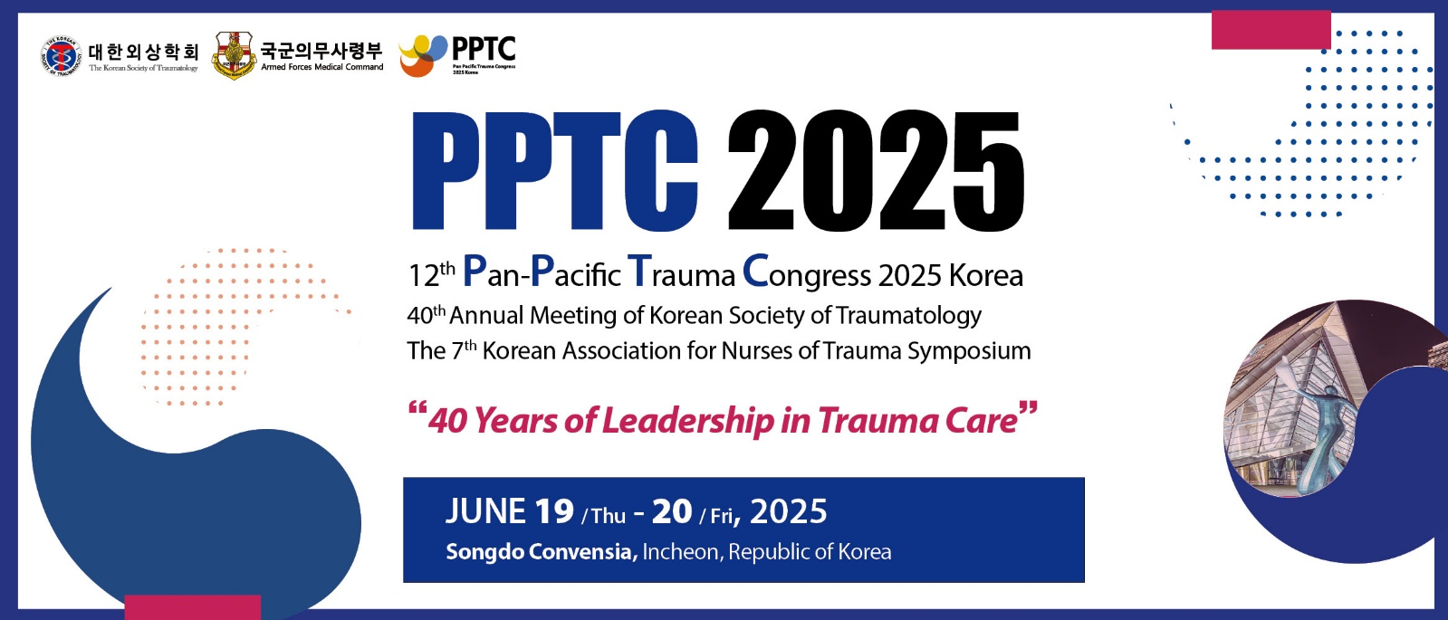

Registration Cancellation Request Form
*Registration cancellation requests can be accepted by Pre-Registration Deadline.

Please fill out this form and submit it to PPTC 2025 Secretariat through e-mail.
*E-mail Address: pptc2025@planmonsters.net

Name
Affiliation
Payment Method
Date
Registration Fee
Card / Remitter
Account No.
Bank Name

[Important Notes]
- If Pre-Registration Deadline is extended, deadline for cancellation request will also be extended.
- Refunds will be made after the congress (within 30 days from the end date of congress).
- For the foreign registrants, more information can be requested for make wire transfer of the amount to refund. (SWIFT Code, etc.)
- Contact Information
- PPTC 2025 Secretariat
- E. pptc2025@planmonsters.net | T. +82-2-6958-7601

